An Efficient Deep Learning Framework for Real-Time Lane Segmentation and Departure Warning

Yavish Sahrawat
Janhvi Singh
Shubham Gangwar
G N S S Abhiram
Guide: Dr. Tauseef Khan

ABSTRACT
Lane detection is tricky for self-driving cars for safe navigation, because roads look different depending on lighting, weather and traffic. We address these challenges using established deep learning architectures called U-Net and Attention U-Net [1, 2]. We trained them to colour in the pixels belonging to lanes on two standard test datasets: Tusimple [3], which is mostly straightforward highway driving and CULane [4], which is much tougher with city streets, bad weather and night time scenes.
On top of just finding lanes, we added a couple of safety features: a warning if a car starts drifting out of its lane and a way to spot other vehicles in the next lane using YOLOv8s [5]. We checked how well our lane-finding worked using the official methods for each dataset. On the TuSimple dataset [3], our Attention U-Net [2] achieved 76% accuracy. However, on the more challenging CULane dataset [4] performance decreased to 36%, primarily due to a high false positive rate.
While our integrated system worked exactly as we imagined but our results indicate that achieving state-of-the-art performance, you probably need AI models specifically designed for lanes and maybe ones that have already learned a lot about images beforehand.

- INTRODUCTION
As vehicles become increasingly automated, the ability to sense the surrounding environment is important for safety and efficiency. Advanced Driver Assistance Systems (ADAS) and Self-Driving Systems (SDS) rely heavily on sensors like cameras to surround the road. Out of everything these systems look for, detecting lane markings is one of the most important tasks. It helps the car know exactly where it is on the road, which is essential for things like staying in the lane or changing lanes safely. When the lane is detected properly, the car can stay centered, avoid drifting and keep things stable. Lane information also powers safety features like Lane Departure Warning (LDW). These systems warn the driver if the car starts slipping out of its lane, something that can easily happen when someone is tires or not paying full attention.
Detecting lane markers in real-world conditions is tough. Lighting changes from day to night and shadows from trees, buildings or tunnels can hide lane lines. Rain reduces visibility and creates reflections and the markings themselves may be faded, worn out or blocked by other vehicles. Road conditions also vary a lot, highways are usually clear, while urban roads have intersections and mixed markings. Nearby vehicles add more clutter and can block the camera’s view, making lane changes riskier if obstacles aren’t detected properly. To handle all this, the system needs to stay accurate in many different situations while still running fast enough for real-time driving decisions.
Older lane detection methods relied on hand-crafted features and classic computer vision techniques like edge detection and Hough transforms, but they often fell apart in messy real-world conditions. Deep learning especially CNNs has become a much stronger solution. Most deep learning models treat lane detection as a semantic segmentation problem [1], where each pixel is labeled as lane or background. This works well, but it usually needs extra post-processing to turn those pixel predictions into clean, usable lane lines, which adds more computation and complexity. Other approaches try to skip this by doing end-to-end learning, directly predicting lane parameters or key points. Some even reframe the task using ideas like row-wise classification [6] to simplify the process.
In this paper, we explore how well the semantic segmentation approach works for lane detection using two well-known models: U-Net and Attention U-Net. [1], [2]. Our main contribution is building and testing a full system that handles multiple parts of lane understanding, not just detection. The system includes:
- Lane detection using segmentation on two popular datasets—the more structured Tusimple dataset [3] and the more challenging, diverse CULane dataset [4].
- A lane departure warning (LDW) system that estimates the vehicle’s position in a bird’s-eye-view and triggers an alert whenever it drifts too far from the lane boundaries.
- An adjacent lane obstacle detection using a lightweight YOLOv8s object detector [5]. It detects nearby vehicles in the camera view and checks, using the lane geometry in bird’s-eye-view, whether any of them pose a risk by entering adjacent lanes.

We evaluate the lane detection module using each dataset’s official metrics [6] (point-based accuracy for Tusimple [3], instance-level F1-score for CULane [4]). We also discuss where the system performs well, where it struggles compared to specialized state-of-the-art methods and qualitatively assess how the LDW and obstacle detection components behave in practice.

- RELATED WORK
  - Traditional Lane Detection Methods
Early lane detection systems used simple geometric methods like running Canny edge detection and then using the Hough transform or RANSAC to find straight or curved lane lines. These techniques were fast but didn’t hold up well in real-world conditions. Shadows from bridges, reflections on wet roads or faded lane markings could easily throw them off. Researchers tried to make them more robust with tricks like sliding windows, vanishing-point estimation and inverse perspective mapping, but these handcrafted methods were still very sensitive to tough scenarios like nighttime driving, bad weather and complex urban roads. Overall, these limits made it clear that rule-based methods just don’t adapt well enough for reliable lane detection in the real world.
  - CNNs and Semantic Segmentation
Convolutional Neural Networks (CNNs) changed lane detection completely. Instead of relying on handcrafted features, CNNs learn what lane markings look like directly from thousands of labelled images. This made semantic segmentation classifying every pixel as lane or background the most common approach.
- U-Net [1] showed that an encoder–decoder design with skip connections can preserve fine details needed for thin lane lines while still understanding the overall scene.
- SCNN [4] improved this by letting information flow horizontally and vertically across the image, helping the network keep long, continuous lane lines from breaking apart.
- ENet-SAD [7] and RESA [8], pushed for real-time speed, bringing inference times down to just a few milliseconds fast enough for 30-fps driving systems.
But pixel-wise segmentation comes with a downside: you still need lots of post-processing to fit lane curves, separate different lanes and remove noise. In many cases, this extra work costs more computation than the network itself. To help with this, some methods use Generative Adversarial Networks (GANs), where the discriminator learns what valid lane shapes look like, making the system more reliable in tricky conditions like poor lighting or bad weather.
  - Attention-Enhanced Architectures
Background clutter makes detecting thin lane lines tricky, especially when the scene is noisy. Attention mechanisms help by focusing the model on the most important features. Attention U-Net [2] does this by adding attention gates to its skip connections, which filter out irrelevant regions and highlight useful lane details. Other methods, like CBAM [9] and SE-ResNet [10] use channel-wise attention to dynamically recalibrate feature maps. These attention-based techniques noticeably improve segmentation quality, especially in tough conditions like low-visibility nighttime scenes, situations that are very common in the CULane dataset.[4].
  - End-to-End Lane Detection
The heavy cost of post-processing pushed researchers toward end-to-end lane detection methods. LaneNet [11] approaches the task as instance segmentation, clustering lane pixels and predicting anchor points for each lane. Models like PINet and PolyLaneNet [12], [13] go further by directly predicting polynomial lane coefficients. Row-wise classification methods [6] rethink the problem entirely: each image row is treated as a small classification task, allowing the model to output lane positions without dense masks or curve fitting making the whole system much lighter. Other approaches take a vertical, stixel-style route, predicting lane positions at a few fixed heights to combine speed with decent structure. These end-to-end methods are much faster often around 10× quicker and have simpler training pipelines, though they trade off a bit of fine-grained precision.
  - Integrated Perception Systems
Lane detection is just one part of a full perception system. Lane Departure Warning (LDW) modules track how far the vehicle is from the center of the lane and warn the driver when it starts drifting. Object detectors like YOLOv5, YOLOv8s [5] and SSD identify vehicles, pedestrians and other obstacles in adjacent lanes.
Most research treats lane detection and object detection as separate tasks, each with its own goals and evaluation methods. But keeping them independent can create extra delays and calibration issues. In our work, we combine everything into one streamlined pipeline: the segmentation model first extracts the lane geometry, which the LDW module immediately uses to calculate drift. At the same time, a YOLOv8s detector [5] identifies finds objects, and their positions are checked against the lane boundaries in a bird’s-eye view.
By integrating these steps logically, we ensure obstacle alerts are lane-aware without needing a complicated shared backbone making the system more practical for real-world safety.

- METHODOLOGY
We designed our system as a single, integrated perception pipeline (figure 1), but it’s easiest to understand by looking at its three main parts. First, a deep learning model detects the lanes. Next, a warning module checks whether the vehicle is drifting out of its lane. Finally, an object detector identifies nearby cars. This section breaks down how each module works and how they all connect.
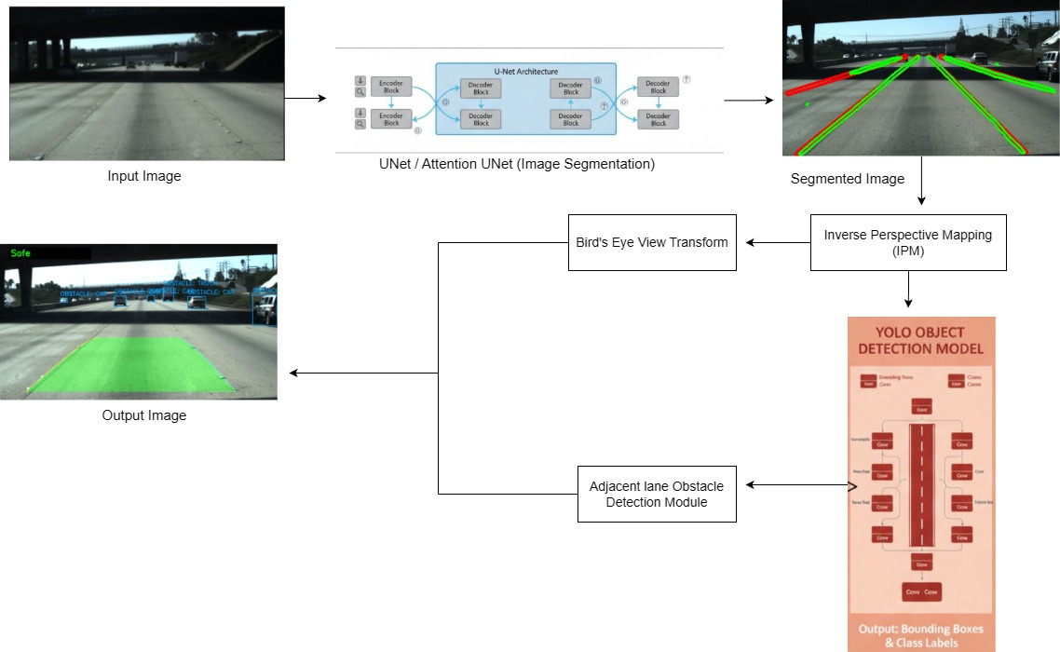
Figure 1: Pipeline diagram showing each step

  - Datasets and Preprocessing
We evaluate our models on two standard datasets used for these purposes (Table 1):
- TuSimple Dataset [3]: This dataset mainly contains highway driving scenes, with clear weather and generally clean footage. The labels are given as sparse (x, y) points along each lane. Since segmentation models need pixel-wise masks, we converted these point annotations into dense lane masks. We did this by drawing the lane lines onto black images (Figure 2a and 2b) using a 5-pixel thickness, and then resizing all masks to 512×288 for training.
- CULane Dataset [4]: This dataset is much tougher. It includes night scenes, heavy shadows, busy city traffic and worn-out lane markings basically everything that makes lane detection hard. Fortunately, it already provides full segmentation masks (Figure 2c and 2d). We cleaned up the file lists into a single JSON manifest for easier loading, and we resized all images and masks to 320×160 to keep training fast and manageable.

Dataset | Test set | validation set | TEst set | total
tusimple | 3626 | 358 | 2782 | 6766
culane | 88880 | 9675 | 34680 | 133235

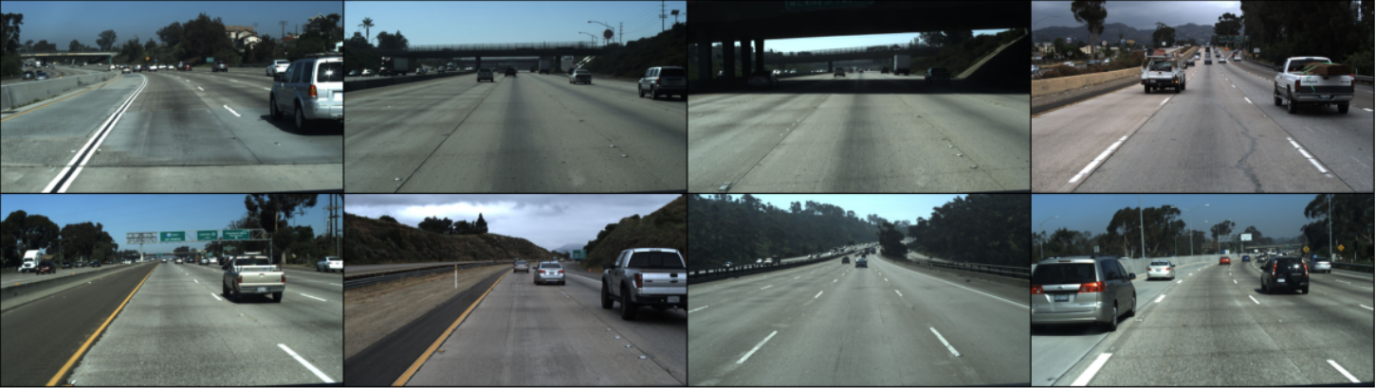
        - TuSimple Sample Images

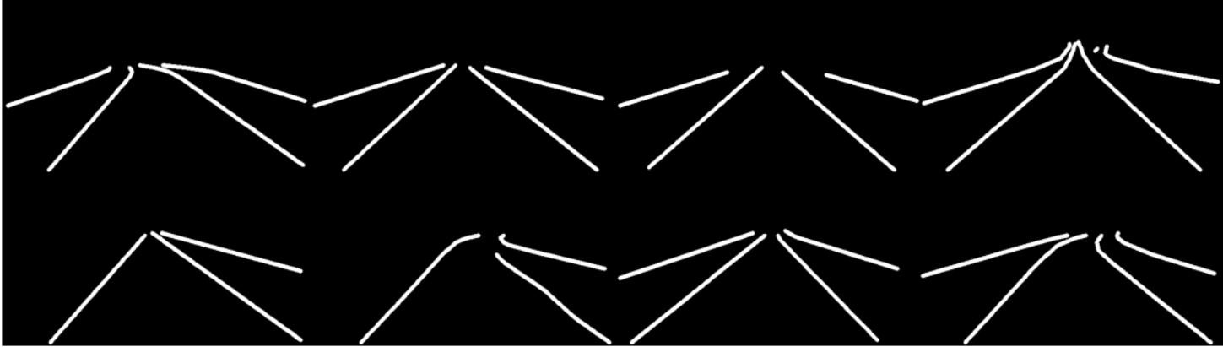
        - TuSimple Corresponding Mask Images
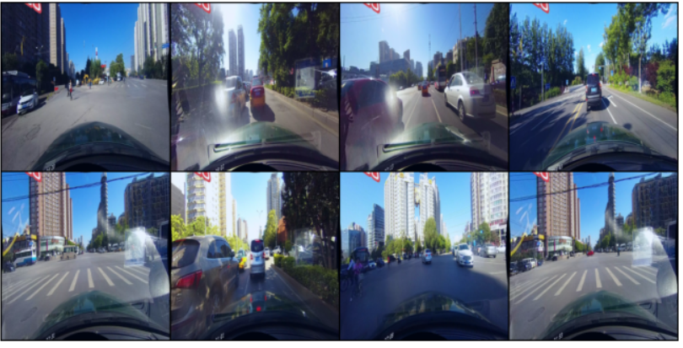
Table 1: Dataset Structure
        - CULane Sample Images
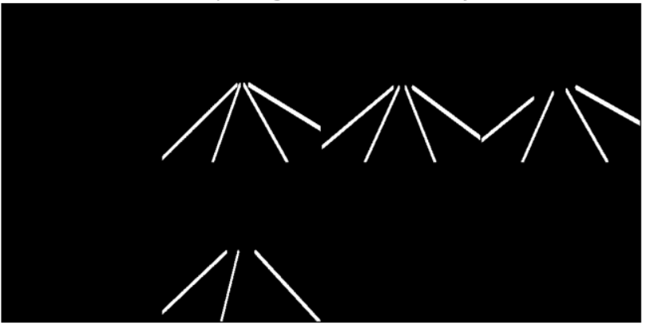
        - CULane Corresponding Mask Images
Figure 2: Sample and Mask Images of both the datasets

  - Model Architectures
We focused on two architectures, a baseline U-Net [1] and our main model, the Attention U-Net [2].
- U-Net [1]: We use this as our baseline model. It’s a classic encoder–decoder architecture with skip connections that help preserve spatial details. These connections let the decoder recover fine-grained information from the encoder while still keeping the broader semantic context. (Figure 3)
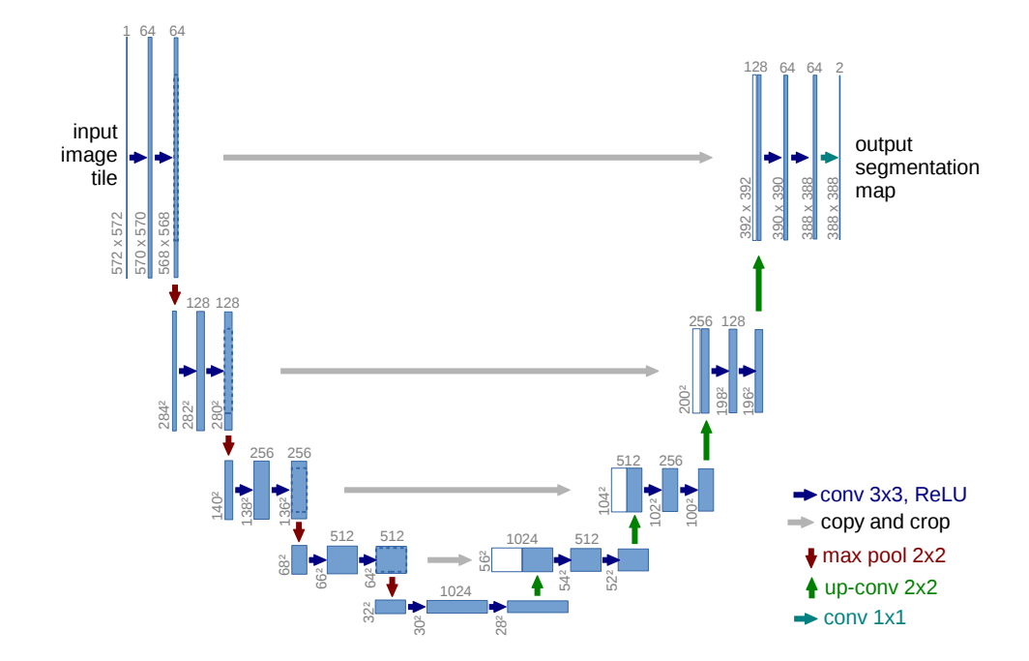
Figure 3: Baseline U-Net Architecture [1]
- Attention U-Net [2]: This improved architecture is our main model. It learns to highlight the important features while downplaying distractions. By adding Attention Gates to the skip connections, the model can ignore irrelevant regions like trees, shadows or buildings and focus more on actual lane markings. This makes it much more reliable in busy, visually cluttered scenes. (Figure 4)
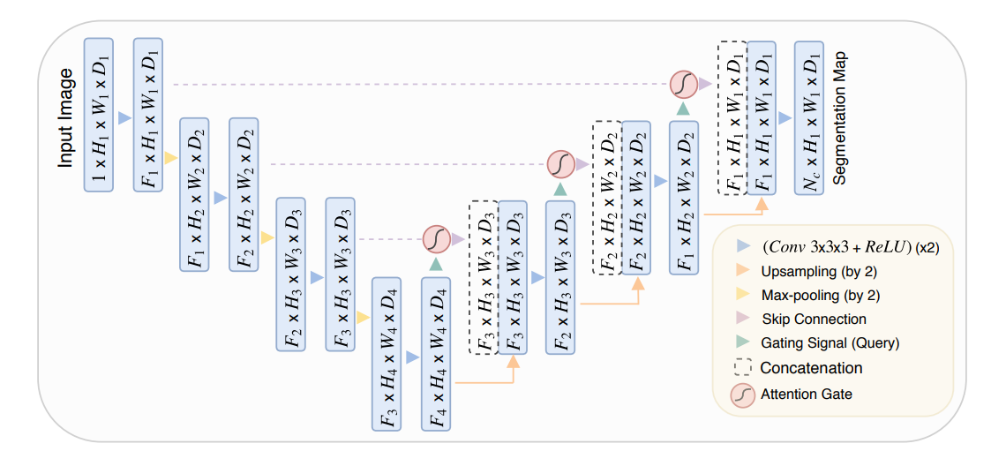
Figure 4: Attention U-Net Segmentation Model [2]
  - The Integrated Safety System
Lane detection is only the starting point its real value comes from how we use it. Both safety features in our system depend on a Bird’s-Eye View (BEV) transform. We take the 2D lane prediction and warp it into a top-down view, almost like looking from a drone. This makes all the geometry much easier to work with.
- Lane Departure Warning (LDW): This module provides lane departure alerts.
    - The predicted mask is warped into the BEV.
    - We fit a smooth 2nd-degree curve (a polynomial) to the left and right lane boundaries.
    - To avoid jitter between frames, we average these fits over the last 7 frames.
    - We find the lane's center at the bottom of the screen and assume our car is in the middle.
    - If the car drifts more than 35% of the lane's width away from the center, we trigger a visual warning.
- Adjacent Lane Obstacle Detection: This module detects vehicles in adjacent lanes.
- We run a separate, pre-trained YOLOv8s model [5] (figure 5) on the original, normal-view frame.
- For every car or truck, it finds, we grab one point: the bottom-center of its bounding box.
- We project just that point into our BEV.
- We check whether the point lies inside or outside our smoothed BEV lane boundaries.
- If it's outside, it's in an adjacent lane and we flag it as a potential obstacle with a green box.
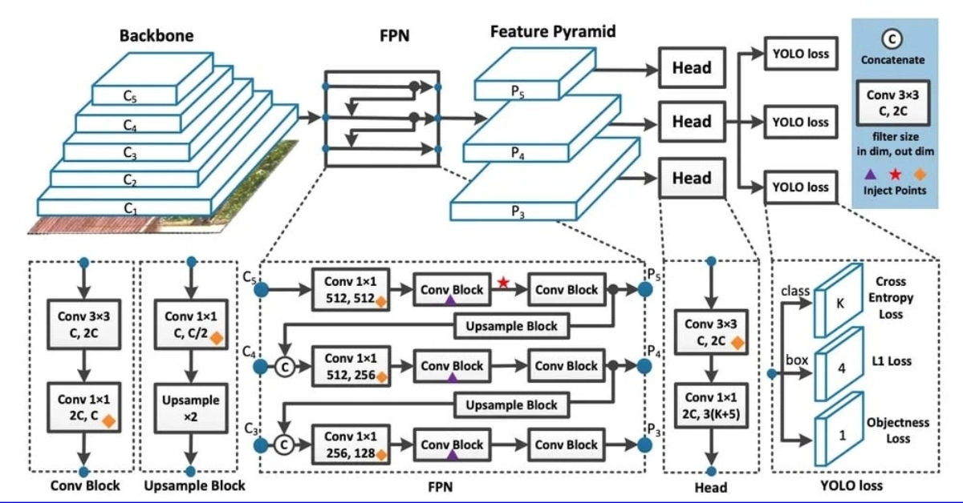
Figure 5: Yolov8 Architecture [19]

  - Training Details
We trained all models with the Adam optimizer and an initial learning rate of 1×10⁻⁴. We also used a ReduceLROnPlateau scheduler, which reduces the learning rate by half if validation performance stops improving for 3 consecutive epochs.
- TuSimple Model: Trained for 50 epochs with a batch size of 8, using a standard BCEWithLogitsLoss.
- CULane Model: Trained for 50 epochs with a larger batch size of 32. For this much harder dataset, we used a combined BCEWithLogitsLoss + DiceLoss to better handle the fact that lanes make up only a tiny fraction of the total pixels. We also used the Albumentations library [18] for more aggressive data augmentation.

  - Evaluation Metrics
To ensure fair evaluation, we used the official scoring rules for each dataset, just as our reference paper did [6].
- TuSimple: This benchmark uses point-based accuracy as the primary metric [3]. A predicted point is considered correct if it falls within 20 pixels horizontally of the ground-truth point. We report this official accuracy (Accuracy=$\frac{Ncorrect}{Ngt}$) plus the official lane-based False Positive (FP) and False Negative (FN) rates.
- CULane: This evaluation is stricter [4]. It uses an instance-level F1-Score. A whole predicted lane only counts as a "True Positive" if its overlap (Intersection over Union or IoU) with the real lane is over 50%. This criterion prevents partial lane detections from being counted as successful predictions. We report the final F1-Score ($\frac{2 x Precision x Recall}{Presision+Recall}$), Precision ($\frac{TP}{TP+FP}$) and Recall ($\frac{TP}{TP+FN}$) based on these instance-level counts.

- EXPERIMENTAL SETUP AND RESULTS
This section covers our testing setup and results, showing how our models performed on both datasets and what that looks like in practice.
  - Setup
We ran all our training and testing on a Kaggle notebook using an NVIDIA P100 GPU. The whole system was built in Python, using PyTorch [16] to build the models, OpenCV [17] for all the image handling, Ultralytics for the YOLOv8s [5] object detector and Albumentations [18] to handle the heavy-duty data augmentation for the CULane dataset [4].
To recap, for the TuSimple dataset, we trained the U-Net for 25 epochs and the Attention U-Net for 50 epochs using BCEWithLogitsLoss with a batch size of 8. For the more complex CULane dataset, both models used a combination of BCEWithLogitsLoss and DiceLoss with a batch size of 32. Training for the Attention U-Net was stopped early at 39 epochs once validation performance plateaued, indicating the model had reached its learning capacity.

  - Quantitative Results
We evaluated our models using the official metrics for each dataset just like in the reference paper [6].
- Tusimple Test Set
On the simple highway dataset [3], we directly compared the baseline U-Net to our Attention U-Net [1], [2]. Table 1 demonstrates that the attention mechanism provides significant performance improvements.

Metric | baseline u – net | attention u – net
official accuracy | 69.30% | 75.63% (+6.3%)
point-level f1-score | 75.65% | 79.66% (+4.0%)
lane fp rate (per image) | 1.6840 | 2.4860
lane fn rate (per umage) | 0.2387 | 0.1373
Table 2: Tusimple Test Set Performance (Point-Based)
The Attention U-Net [2] outperformed the baseline, showing a 6.3% increase in accuracy. This improvement confirms that the attention gates effectively enhance feature selectivity. However, while it achieved higher recall and reduced missed lanes, it also produced more false positives by occasionally detecting non-existent lane markings. Check results from Figure 6a.
- CULane Validation Set
On the more challenging CULane dataset [4] performance was interesting. Refer Table 2.
metric | baseline u – net | attention u – net
instance f1 – score | 39.34% | 35.83%
instance precision | 32.73% | 29.54%
instance recall | 49.28% | 45.52%
Table 3: CULane Validation Set Performance (Instance-Level)
On this much harder dataset, the baseline U-Net [1] actually performed better. The Attention U-Net [2], which helped so much on the clean highway, struggled with CULane's complex visual environments. It had lower precision and lower recall, showing both higher false positive and false negative rates compared to simpler baseline model. Check results from Figure 6b.

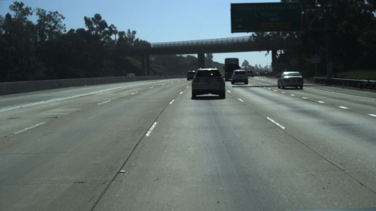 | 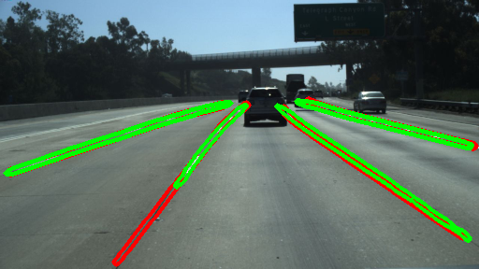
      - TuSimple Results

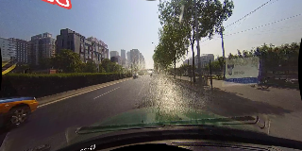 | 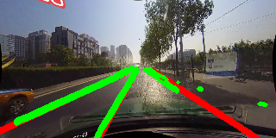
      - CULane Results

Figure 6: Lane Detection results (green) compared with ground truth (red)
- Comparison to State-of-the-Art
DATASET | MODEL | ACCURACY | PRECISION | RECALL | F1-SCORE
TUSIMPLE | E2E-LMD (R-18) | 96.04% | - | - | -
TUSIMPLE | BASE U-NET | 69.30% | 83.28% | 69.30% | 75.65%
TUSIMPLE | ATT. U-NET | 75.63% | 84.13% | 75.63% | 79.66%
CULANE | E2E-LMD (R-18) | - | 76.5% | 71.8% | 74%
CULANE | BASE U-NET | 24.49 | 32.73% | 49.28% | 39.34%
CULANE | ATT. UNET | 21.83 | 29.54% | 45.52% | 35.83%
For comprehensive evaluation, we compared our both the models on each dataset to the specialized model from our reference paper [6].
Table 4: Performance Comparison with SOTA
These results show a clear performance gap. Our models, which are general-purpose segmentation tools trained from scratch, are 20-30+ points behind the specialized, pre-trained architecture from the paper.

  - Qualitative and Integrated System Analysis
On clean Tusimple roads (Figure 7a), our models produced accurate lane segmentation. But on CULane (Figure 7b), the visuals matched the numbers, models often confused shadows and road edges for lane markings, leading to lower precision. The integrated safety features worked as expected but clearly depended on the accuracy of the lane detection itself.
- Lane Departure Warning: Performed reliably, with seven-frame averaging ensuring stable lane boundaries. The system correctly triggered a “Lane Departure!” alert when the vehicle crossed the 35% threshold.
- Obstacle Detection: Worked as intended. YOLOv8s [5] accurately detected nearby vehicles, and the bird’s-eye view correctly flagged cars in adjacent lanes as “OBSTACLE” (Figure 7).
However, both features rely entirely on the lane detector. When the detector misclassified shadows as lanes, the obstacle module sometimes flagged cars in the ego lane as adjacent obstacles, and the departure warning triggered false alerts. In short, the safety system is only as reliable as the perception it’s built on.

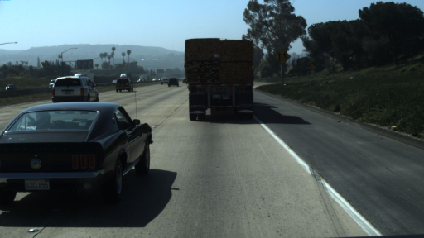 | 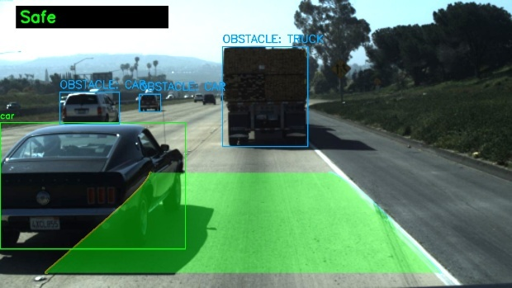
      - TuSimple Final Output

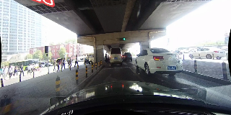 | 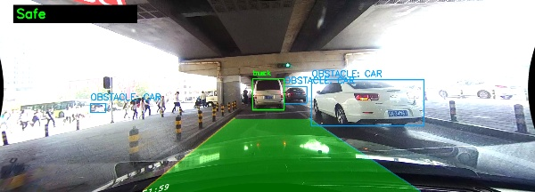
      - CULane Final Output

Figure 7: Final output for each dataset

- CONCLUSION AND FUTURE WORK
  - Conclusion
This paper presented an integrated perception system for autonomous driving, combining lane detection, lane departure warning (LDW) and adjacent-lane obstacle detection. We evaluated both baseline U-Net and an Attention U-Net [1], [2] on the structured TuSimple and the challenging CULane datasets [3], [4].
The Attention U-Net performed better on the simpler TuSimple dataset (75.6% vs. 69.3%), showing improved focus under clean conditions. However, on the complex CULane dataset, the baseline U-Net achieved higher accuracy (39.3% F1), as attention mechanisms often misfocused on shadows and clutter.
While the LDW and YOLOv8s-based modules [5] functioned correctly, their reliability depended on lane detection quality errors in segmentation led to false alerts. Overall, general-purpose models trained from scratch are useful baselines but lack the robustness needed for real-world driving, where specialized architectures and pre-trained backbones remain essential.
  - Future Work
Based on our findings, we propose several key directions for future research:
    - Integrate Pre-trained Backbones: Replace the randomly initialized U-Net encoder with a pre-trained backbone[14], such as a ResNet-34 to leverage learned visual features, improving accuracy and reducing training time.
    - Add Post-Processing Filters: Introduce filters to reduce false positives by rejecting lane predictions that don’t meet certain geometric or confidence thresholds, helping remove noise from shadows and road artifacts.
    - Explore Specialized Architectures: Implement the row-wise classification approach from our reference paper [6] to directly compare segmentation-based and end-to-end lane detection methods.
    - Develop a Multi-Task Model: Develop a unified multi-task learning (MTL) system with a shared backbone and multiple output heads for lane segmentation, object detection and drivable area segmentation to improve efficiency and overall performance.

- REFERENCES
[1] O. Ronneberger, P. Fischer, and T. Brox, "U-Net: Convolutional networks for biomedical image segmentation," in Proc. Int. Conf. Medical Image Computing and Computer-Assisted Intervention (MICCAI), Munich, Germany, 2015, pp. 234-241. [Online]. Available: https://arxiv.org/abs/1505.04597
[2] O. Oktay, J. Schlemper, L. L. Folgoc, M. Lee, M. Heinrich, K. Misawa, K. Mori, S. McDonagh, N. Y. Hammerla, B. Kainz, B. Glocker, and D. Rueckert, "Attention U-Net: Learning where to look for the pancreas," arXiv preprint arXiv:1804.03999, 2018. [Online]. Available: https://arxiv.org/abs/1804.03999
[3] TuSimple, "TuSimple lane detection challenge dataset," 2017. [Online]. Available: https://www.kaggle.com/datasets/manideep1108/tusimple
[4] X. Pan, J. Shi, P. Luo, X. Wang, and X. Tang, "Spatial as deep: Spatial CNN for traffic scene understanding," in Proc. AAAI Conf. Artificial Intelligence, 2018, pp. 7276-7283. [Online]. Available: https://xingangpan.github.io/projects/CULane.html
[5] G. Jocher, A. Chaurasia, and J. Qiu, "Ultralytics YOLOv8," 2023. [Online]. Available: https://github.com/ultralytics/ultralytics
[6] S. Yoo, H. Lee, H. Myeong, S. Yun, H. Park, J. Cho, and D. Kim, "End-to-end lane marker detection via row-wise classification," in Proc. IEEE/CVF Conf. Computer Vision and Pattern Recognition Workshops (CVPRW), 2020, pp. 1006-1007. [Online]. Available: https://arxiv.org/abs/2005.08630
[7] Y. Hou, Z. Ma, C. Liu, and C. C. Loy, "Learning lightweight lane detection CNNs by self attention distillation," in Proc. IEEE Int. Conf. Computer Vision (ICCV), 2019, pp. 1013-1021. [Online]. Available: https://arxiv.org/abs/1908.00821
[8] T. Zheng, H. Fang, Y. Zhang, W. Tang, Z. Yang, H. Liu, and D. Cai, "RESA: Recurrent feature-shift aggregator for lane detection," in Proc. AAAI Conf. Artificial Intelligence, 2021. [Online]. Available: https://arxiv.org/abs/2008.13719
[9] S. Woo, J. Park, J. Y. Lee, and I. S. Kweon, "CBAM: Convolutional block attention module," in Proc. European Conf. Computer Vision (ECCV), 2018, pp. 3-19. [Online]. Available: https://arxiv.org/abs/1807.06521
[10] J. Hu, L. Shen, and G. Sun, "Squeeze-and-excitation networks," in Proc. IEEE Conf. Computer Vision and Pattern Recognition (CVPR), 2018, pp. 7132-7141. [Online]. Available: https://arxiv.org/abs/1709.01507
[11] D. Neven, B. De Brabandere, S. Georgoulis, M. Proesmans, and L. Van Gool, "Towards end-to-end lane detection: an instance segmentation approach," in Proc. IEEE Intelligent Vehicles Symp. (IV), 2018, pp. 286-291. [Online]. Available: https://arxiv.org/abs/1802.05591
[12] S. Ko, J. Ko, S. Lee, S. Mualla, E. Park, and S. Choi, "Key points estimation and point instance segmentation approach for lane detection," IEEE Trans. Intelligent Transportation Systems, vol. 23, no. 7, pp. 8949-8958, 2022. [Online]. Available: https://arxiv.org/abs/2002.06604
[13] L. Tabelini, R. Berriel, T. M. Paixao, C. Badue, A. F. De Souza, and T. Oliveira-Santos, "PolyLaneNet: Lane estimation via deep polynomial regression," in Proc. Int. Conf. Pattern Recognition (ICPR), 2021, pp. 6150-6156. [Online]. Available: https://arxiv.org/abs/2004.10924
[14] K. He, X. Zhang, S. Ren, and J. Sun, "Deep residual learning for image recognition," in Proc. IEEE Conf. Computer Vision and Pattern Recognition (CVPR), 2016, pp. 770-778. [Online]. Available: https://arxiv.org/abs/1512.03385
[15] J. Deng, W. Dong, R. Socher, L. J. Li, K. Li, and L. Fei-Fei, "ImageNet: A large-scale hierarchical image database," in Proc. IEEE Conf. Computer Vision and Pattern Recognition (CVPR), 2009, pp. 248-255. [Online]. Available: https://ieeexplore.ieee.org/document/5206848
[16] A. Paszke et al., “PyTorch: An Imperative Style, High-Performance Deep Learning Library,” in Advances in Neural Information Processing Systems 32, 2019, pp. 8024–8035. [Online]. Available: https://proceedings.neurips.cc/paper/2019/hash/bdbca288fee7f92f2bfa9f7012727740-Abstract.html
[17] G. Bradski, “The OpenCV Library,” Dr. Dobb's Journal of Software Tools, 2000. [Online]. Available: https://www.drdobbs.com/open-source/the-opencv-library/184404319
[18] A. Buslaev, A. Iglovikov, E. Khvedchenya, V. Parinov, M. Druzhinin, and A. Kalinin, “Albumentations: Fast and Flexible Image Augmentations,” Information, vol. 11, no. 2, p. 125, 2020. [Online]. Available: https://www.mdpi.com/2078-2489/11/2/125
[19] YOLOv8.org, "What is YOLOv8?," YOLOv8.org, 2024. [Online]. Available: https://yolov8.org/what-is-yolov8/

